Adding a new user in linux:



Add new user to a group:

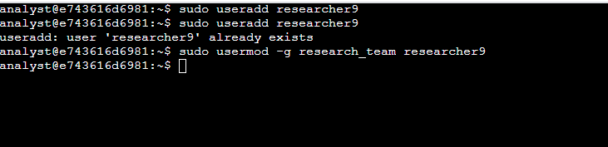

Assign ownership of the file:

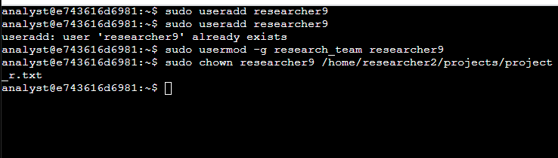

Appending and adding the user to a secondary group:

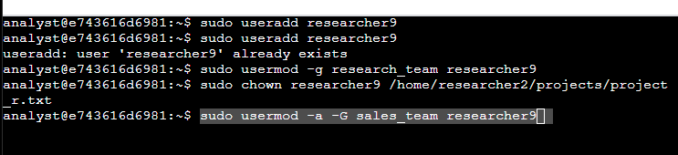

Deleting a user but need to del group first to del user (next following image)

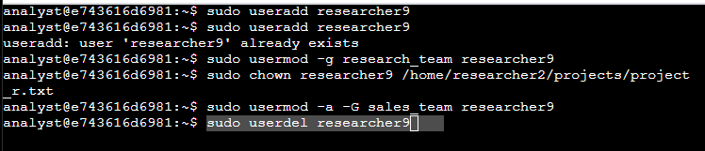

Deleting group before user since when creating a new user it creates a group along with it

